1. Largest among three numbers using ternary conditional operator

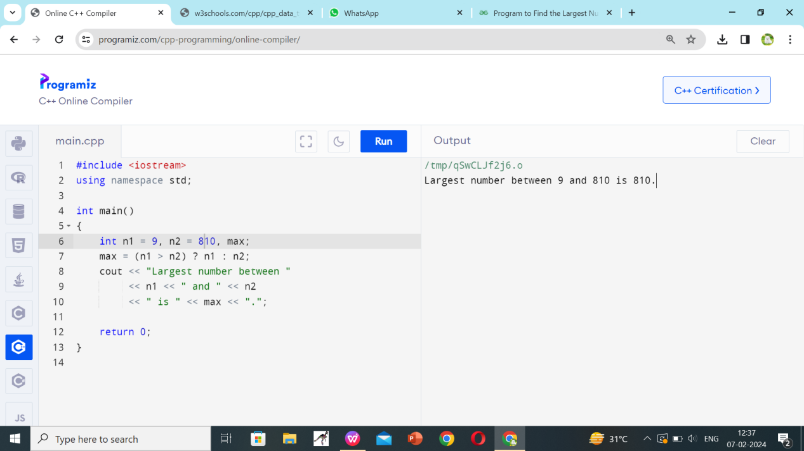

1. Program to check two numbers are equal or not using ternary conditional operator

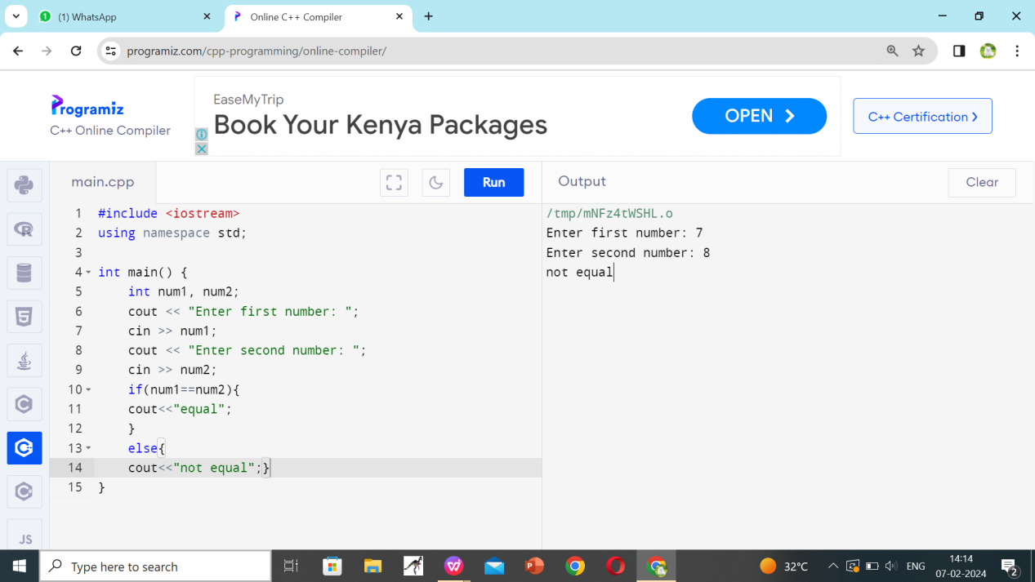

1. Program to check the integer is divisible by 3 or not using ternary conditional 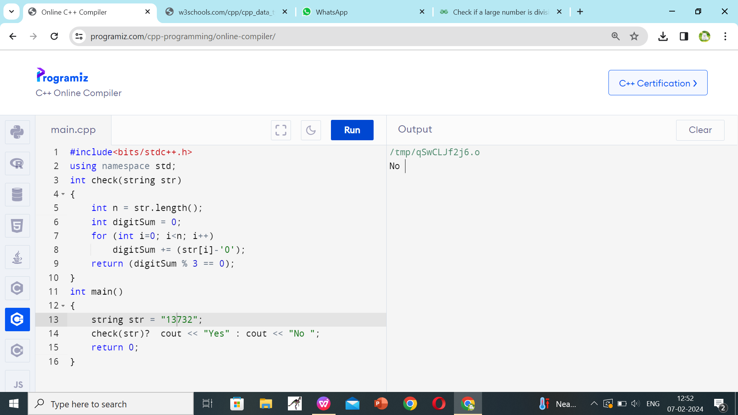
2. Program to print numbers from 1 to 10 using for loop

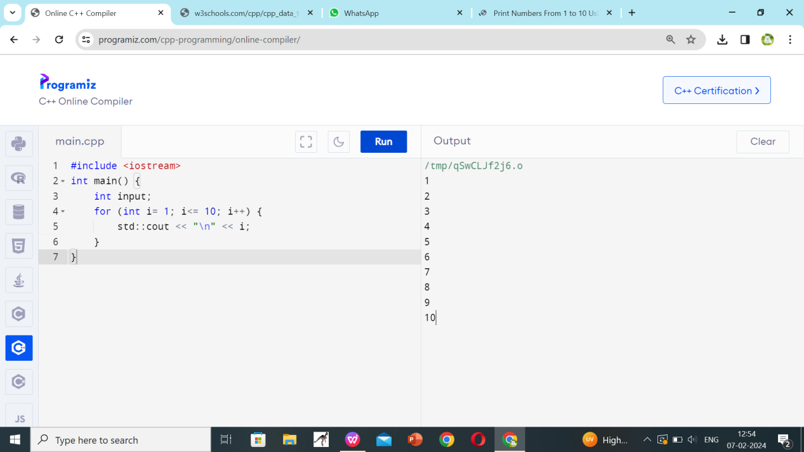

1. Factorial of a number using for loop

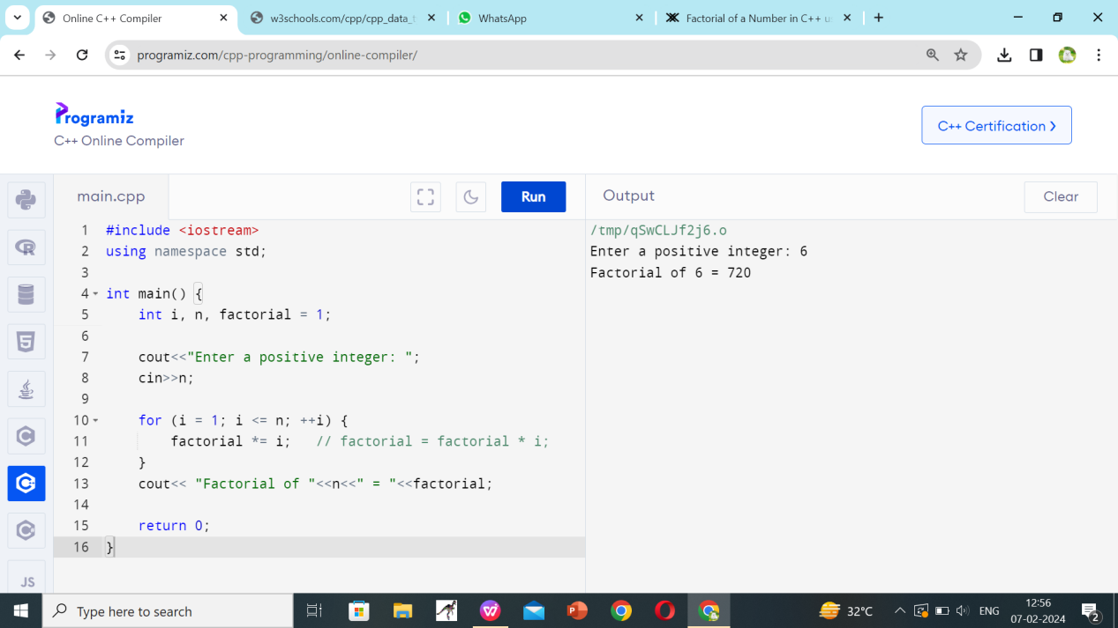

16.Print multiplication table using for loop

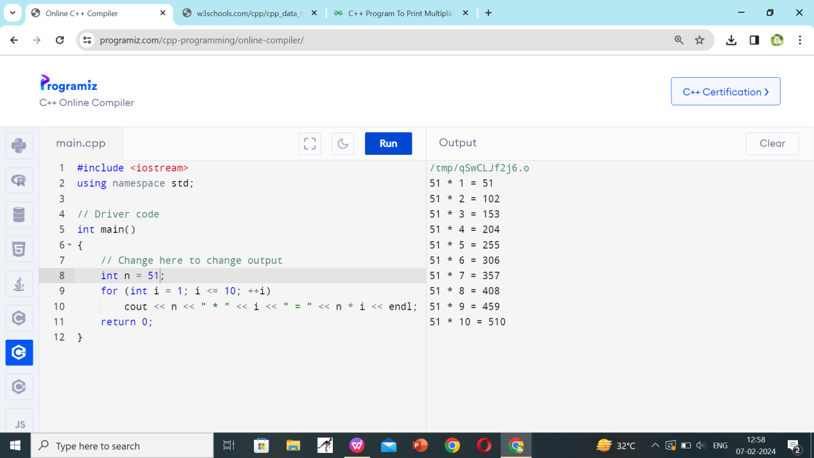

1. Print multiplication table using for loop

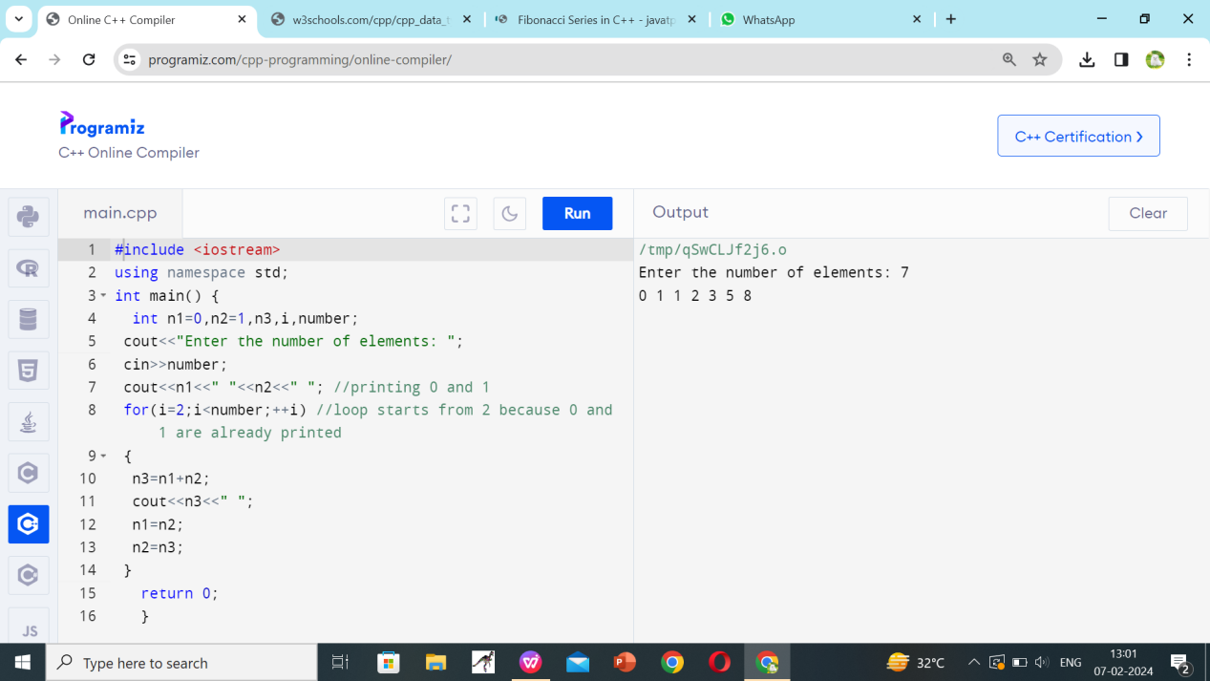

18.Prime number using for loop

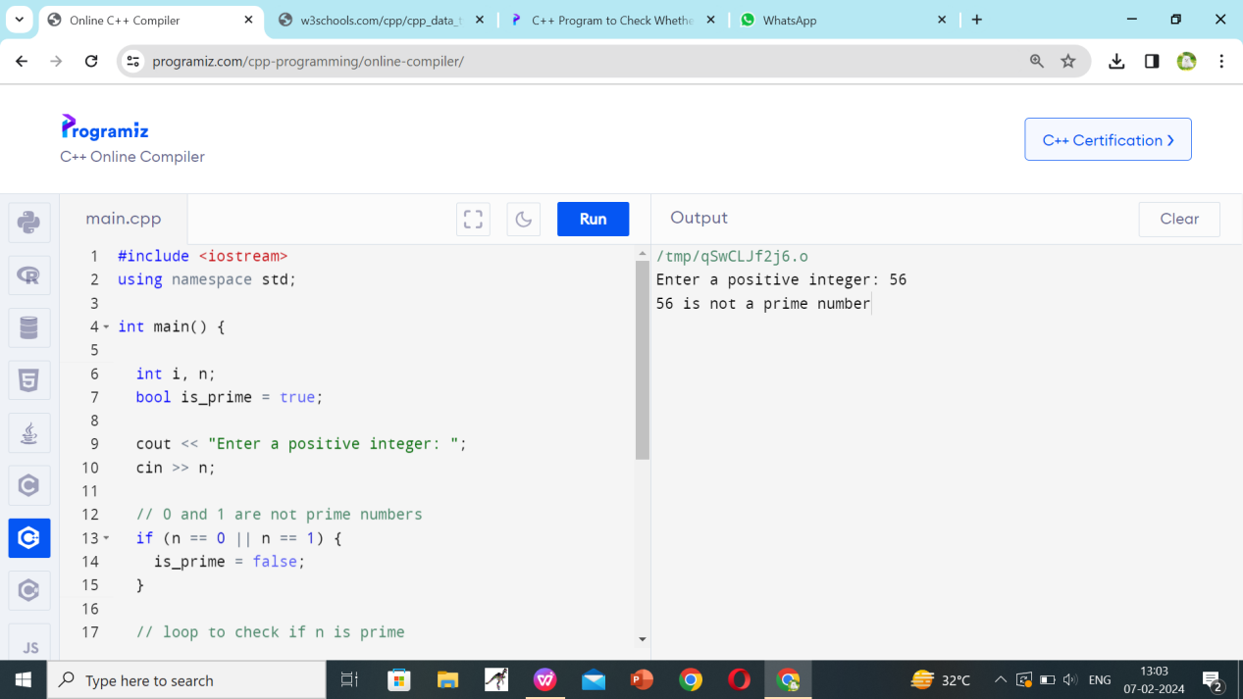

19.Check the string is palindrome or not using while loop

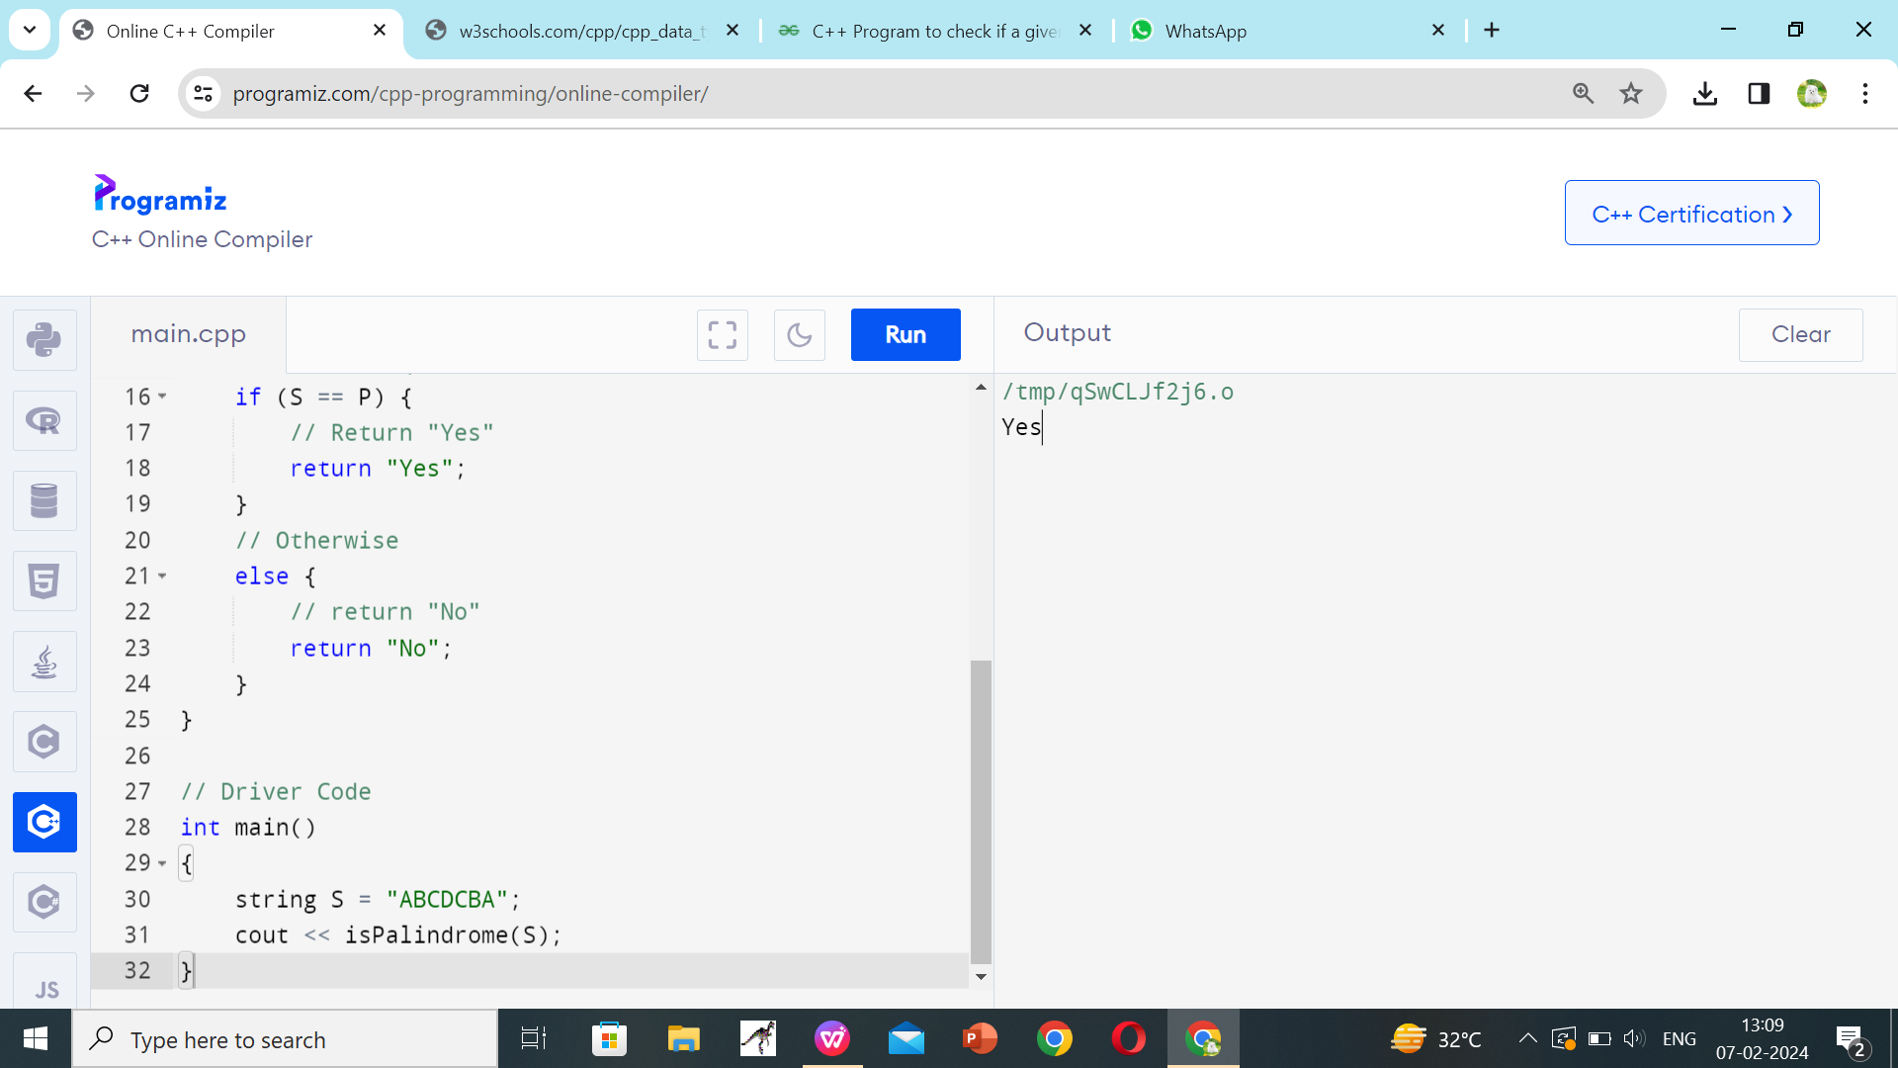

1. Sum of all digits using while loop (n=123 output:1+2+3=6)

